**How to run Python scripts in any Cpanel Hosting**

If you wish to run Python scripts in your hosting account, you can create and edit them in two ways: either in cPanel or via SSH.   
  
**To create and edit Python script in cPanel use the following steps:**  
  
1. Log in to your **cPanel**:  
2. Go to section**Files** > **File Manager**:   
  
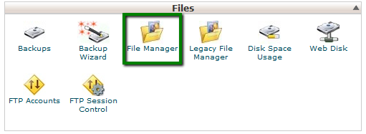  
  
  
3. You can choose whether you want to run the script in the cgi-bin folder or outside of it.   
  
**The cgi-bin**folder contains executable **CGI** scripts. If the file should be placed out of the cgi-bin folder,**.htaccess** should be created additionally.   
  
4. In order to run the Python script in the cgi-bin folder follow the steps: 

* Go to the **cgi-bin** folder
* Create a file with a*.py* extension, for example *nctest.py* in the */home/cPuser/public_html/cgi-bin*directory (where cPuser is your actual cPanel username).

5. In order to create the file, click**New File**> specify the name of the file with the required extension and click **Create New File**:   
  
  
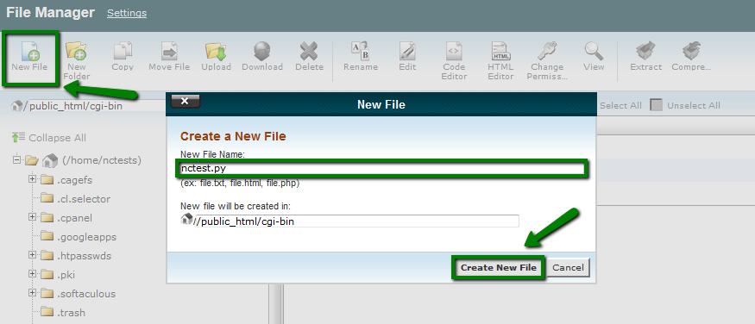  
  
  
6. Change the permission of the file to **0755**  
  
**NOTE:** Files are created with default permissions**0644**. The *.py* file will become executable when the permissions are changed to **0755**.   
  
7. In order to change the permissions of the file you need to **select the file**> click **Change Permissions** > **Mark Execute for User, Group, World** columns and click **Change Permissions**:   
  
  
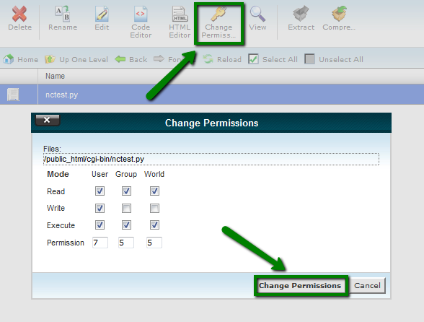  
  
  
8. Open the file, click **Edit**and add the code.   
  
We will add the following script for testing purposes:   
  
*#!/usr/bin/python   
  
print "Content-type: text/html\n\n"  
print "How to run Python scripts in cPanel"*  
**NOTE:**The file should start with the path to the Python scripts that is */usr/bin/python* on our servers, but you can run the *whereis python* command via SSH to check the directory.   
  
Now the script should work using *http://domain.com/cgi-bin/nctest.py*If you would like to run the Python file not in the cgi-bin folder (in public_html or any other directory), it is necessary to add the following code to the*.htaccess* file in the same directory where the Python script is placed:   
  
*Options +ExecCGI   
AddHandler cgi-script .py*  
  
  
**To create and edit the Python script via SSH use the following steps:**  
  
1. Connect to cPanel account via [SSH](https://www.namecheap.com/support/knowledgebase/article.aspx/1016/89/how-to-access-my-hosting-account-via-ssh)  
2. Go to thte **cgi-bin** directory running *cd ./public_html/cgi-bin*  
  
To check that you are in the correct directory, you can run the command: *pwd*  
  
  
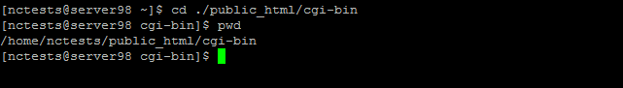  
  
3. Create the file with the .py extension, for example,*nctest.py* in the */home/cPuser/public_html/cgi-bin*directory (where cPuser is your cPanel username).   
  
To create the file in the current directory, type *touch nctest.py*  
  
Once done, you can check that the file is present in the directory now running the command*ls*  
  
  
  
  
  
4. Change the permission of the file to **0755** running the command below:   
  
*chmod 755 /home/cPuser/public_html/cgi-bin/nctest.py*  
(where cPuser is your actual cPanel username)   
  
  
https://namecheap.simplekb.com/SiteContents/2-7C22D5236A4543EB827F3BD8936E153E/media/pytonscripts6.png  
  
5. Open the file and add the necessary code.   
  
You can open the file with one of the editors like *nano*. To open the file with nano, use the following command:   
*nano nctest.py*  
  
We will add the following code for testing purposes:   
  
*#!/usr/bin/python   
  
print "Content-type: text/html\n\n"   
print "How to run Python scripts in cPanel"*  
  
  
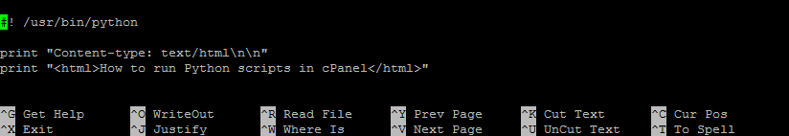  
  
  
**NOTE:**The file should start with the path to the Python scripts that is */usr/bin/python* on our servers, but you can run the *whereis python* command via SSH to check the directory.   
  
To save the changes, click **Crtl+O**and press Enter for Windows or **Command+O** for Mac OS.   
  
Now the script should work using *http://domain.com/cgi-bin/nctest.py*  
  
If you would like to run the Python script not in the cgi-bin folder, it is necessary to add a special code to the **.htaccess** file in the same directory where the Python file is placed.   
  
6. Create**.htaccess** if it is not present in the required directory running *touch .htaccess*  
  
  
https://namecheap.simplekb.com/SiteContents/2-7C22D5236A4543EB827F3BD8936E153E/media/pytonscripts8.png  
  
  
7. Open the **.htaccess** file running *nano .htaccess* and add the following code:   
  
*Options +ExecCGI   
AddHandler cgi-script .py*  
  
Click **Crtl+O**and press **Enter**for Windows or **Command+O** for Mac OS to save the changes:   
  
  
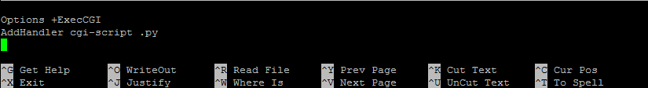  
  
  
Now you can check the script at *http://domain.com/nctest.py*  
  
  
 That's it!